# Evaluation Rubric :

|  |  |  |
| --- | --- | --- |
| **Evaluation parameter** | **Does not meet specifications** | **Meets specifications** |
| **Problem statement** |  | **2** |
| Problem Statement must be clearly defined |  | **√** |
| Expected input and output formats must be described |  | **√** |
| Explain the problem statement with an example(if applicable) |  | **√** |
| **Expected input & output** |  | **3** |
| Minimum of 5 test cases (if applicable) |  | **√** |
| Coverage |  | **√** |
| Border condition |  | **√** |
| Unexpected inputs |  | **√** |
| **Solution** |  | **5** |
| The correctness of the solution. |  | **√** |
| Check for all the elements (tokens) of the problem (Assignment, Arithmetic, conditional, relational, input, output etc) |  | **√** |
| **Trace Table :** |  | **5** |
| Columns are variables, conditions, print statements |  | **√** |
| Order |  | **√** |
| Trace table for each function(If applicable) |  | **√** |
| labeling the columns |  | **√** |
| Coverage (conditions, iterations... etc) |  | **√** |
| **Final Result** |  | **2** |
| Executable File Submission |  | **√** |
| **Executable File** |  | **3** |
| Check with all test cases |  | **√** |

# 

**Problem Statement**: **(2 Marks)**

Given n, Find the sum of even valued Fibonacci terms for upto n terms

Example:

Input : 8

Output: 10

**Test cases: (3 Marks)**

|  |  |
| --- | --- |
| **Expected Input** | **Expected Output** |
| 8 | 10 |
| 2 | 2 |
| -1 | invalid |
| 5 | 2 |
| a | invalid |

**Solution**: **(5 Marks)**

**Step 1:** START

Step 2: Input value of n   
 Step 2.1: if !isinteger(n) or n<0, print “invalid”, go to step 8

Step 3: Set a=0,i=1 , sum=0// first,second elements of fib terms

Step 4: While(i<=n) (true=goto step 4.1..) else goto step 8

Step 4.1: temp=a+i

Step 4.1.1: a=i

Step 4.1: 2=temp( goto step 4.2 if true or goto step 7)

Step 4.2: Output fibonacci terms

Step 5: Check if(a%2==0) //Finding even fib terms (goto step 5.1 if true else goto step 4)

Step 5.1: Output even fibonacci terms ( true=goto step 6)

Step 6: sum=sum+a // Count even fib terms (goto step 7)

Step 6.1: Output sum goto step 7

Step 7: i=i+1

Step 8: END

Pseudocode:

**START**

**QUERY 'n', n**

**a=0**

**i=1**

**sum=0**

**WHILE i<=n DO**

**temp=a+i**

**a=i**

**i=temp**

**WRITE 'fibonacci term ',a**

**IF a%2=0 THEN**

**WRITE 'Even fibonacci term: ',a**

**sum=sum+a**

**ENDIF**

**ENDWHILE**

**i=i+1**

**WRITE sum**

**WRITE " sum(even_fibonacci_terms) ",sum**

**END**

**Trace Table** : **(5 Marks)**

Test case 1:

|  |  |  |  |  |  |  |  |  |  |  |  |  |
| --- | --- | --- | --- | --- | --- | --- | --- | --- | --- | --- | --- | --- |
| n | a | i | sum | while(i<=n) | temp=a+i | **a=i** | i=temp | **IF a%2=0** | **Write :'Even'** | **sum=sum+a** | **i=i+1** | Write: sum |
| 2 | 0 | 1 | 0 | 1<=2 | 1 | 1 | 1 | 0 | 0 |  | 2 |  |
|  |  | 2 | 0 | 2<=2 | 2 | 2 | 2 | 1 | 'Even' | 0+2 | 3 |  |
|  |  |  | 2 | 3<=2 |  |  |  |  |  |  |  | sum: 2 |
|  |  |  |  |  |  |  |  |  |  |  |  |  |
|  |  |  |  |  |  |  |  |  |  |  |  |  |

Test case 2:

|  |  |  |  |  |  |  |  |  |  |  |  |  |
| --- | --- | --- | --- | --- | --- | --- | --- | --- | --- | --- | --- | --- |
| n | a | i | sum | while(i<=n) | temp=a+i | **a=i** | i=temp | **IF a%2=0** | **Write :'Even'** | **sum=sum+a** | **i=i+1** | Write: sum |
| 3 | 0 | 1 | 0 | i<=3 | 1 | 1 | 1 | 0 | 0 | 0 | 2 |  |
|  | 1 | 2 | 0 | 2<=3 | 2 | 2 | 2 | 1 | 'Even' | 0+2 | 3 |  |
|  | 2 | 3 | 2 | 3<=3 | 3 | 3 | 3 | 0 | 0 | 2 | 4 |  |
|  |  |  |  | 4<=3 |  |  |  |  |  |  |  | sum: 2 |
|  |  |  |  |  |  |  |  |  |  |  |  |  |

Test case 3:

|  |  |  |  |  |  |  |  |  |  |  |  |  |
| --- | --- | --- | --- | --- | --- | --- | --- | --- | --- | --- | --- | --- |
| n | a | i | sum | while(i<=n) | temp=a+i | **a=i** | i=temp | **IF a%2=0** | **Write :'Even'** | **sum=sum+a** | **i=i+1** | Write: sum |
| -1 | 0 | 1 | 0 | 1<=-1 |  |  |  |  |  |  |  |  |
|  |  |  |  | " " |  |  |  |  |  |  |  | sum:0 |

Test case 4:

|  |  |  |  |  |  |  |  |  |  |  |  |  |
| --- | --- | --- | --- | --- | --- | --- | --- | --- | --- | --- | --- | --- |
| n | a | i | sum | while(i<=n) | temp=a+i | **a=i** | i=temp | **IF a%2=0** | **Write :'Even'** | **sum=sum+a** | **i=i+1** | Write: sum |
| 4 | 0 | 1 | 0 | 1 | 1 | 1 | 1 | 0 | 0 | 0 | 2 |  |
|  | 1 | 2 | 0 | 1 | 2 | 2 | 2 | 1 | 'Even' | 2 | 3 |  |
|  | 2 | 3 | 2 | 1 | 3 | 3 | 3 | 0 | 0 | 2 | 4 |  |
|  | 3 | 4 | 2 | 1 | 4 | 4 | 4 | 1 | 'Even' | 6 | 5 |  |
|  |  | 5 | 6 | 0 |  |  |  |  |  |  |  | sum: 6 |

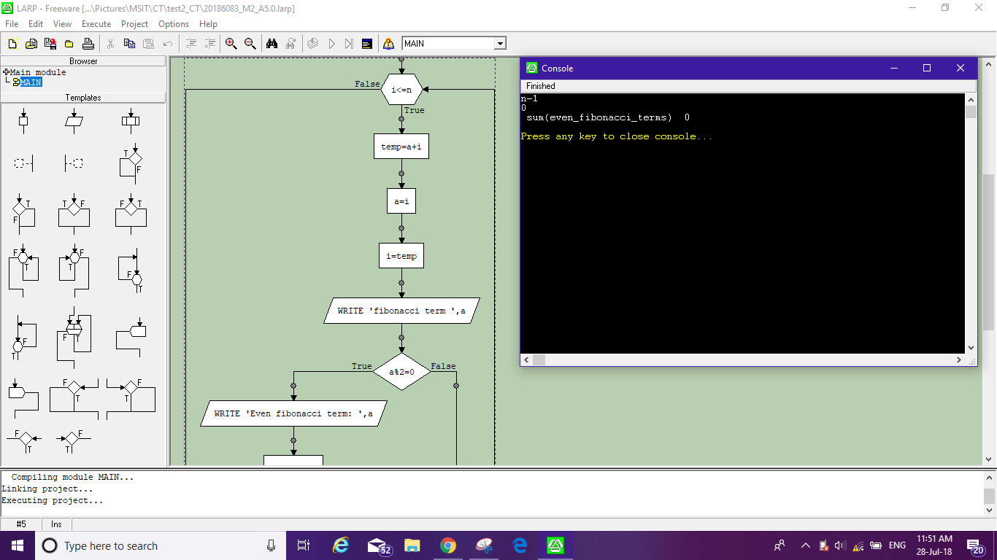

**Final Result :** **(2 Marks)**

|  |  |  |  |
| --- | --- | --- | --- |
| **Expected input** | **Expected output** | **Actual output** | **Test result** |
| 8 | 10 | 10 | 1 |
| 2 | 2 | 2 | 1 |
| -1 | 0 | 0 | 0 |
| 5 | 2 | 2 | 1 |
| 4 | 2 |  |  |